Jan 19, 2016, 08:11am

Why Attitude Is More Important Than IQ
Travis Bradberry
When it comes to success, it’s easy to think that people blessed with brains are inevitably going to leave the rest of us in the dust. But new research from Stanford University will change your mind (and your attitude).
Psychologist Carol Dweck has spent her entire career studying attitude and performance, and her latest study shows that your attitude is a better predictor of your success than your IQ. Dweck found that people’s core attitudes fall into one of two categories: a fixed mindset or a growth mindset.
With a fixed mindset, you believe you are who you are and you cannot change. This creates problems when you’re challenged because anything that appears to be more than you can handle is bound to make you feel hopeless and overwhelmed.
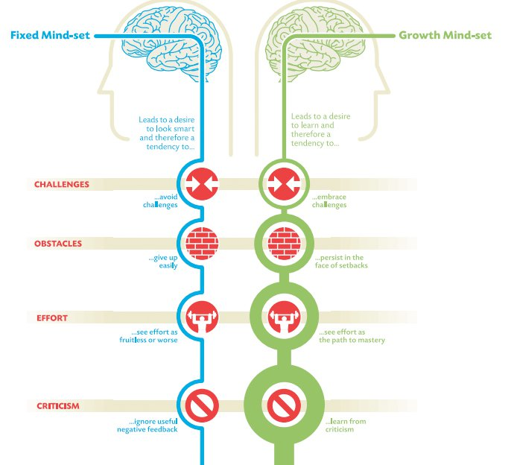

People with a growth mindset believe that they can improve with effort. They outperform those with a fixed mindset, even when they have a lower IQ, because they embrace challenges, treating them as opportunities to learn something new.
Common sense would suggest that having ability, like being smart, inspires confidence. It does, but only while the going is easy. The deciding factor in life is how you handle setbacks and challenges. People with a growth mindset welcome setbacks with open arms.
According to Dweck, success in life is all about how you deal with failure. She describes the approach to failure of people with the growth mindset this way,“Failure is information—we label it failure, but it’s more like, ‘This didn’t work, and I’m a problem solver, so I’ll try something else.’”
Regardless of which side of the chart you fall on, you can make changes and develop a growth mindset. What follows are some strategies that will fine-tune your mindset and help you make certain it’s as growth oriented as possible.
Don’t stay helpless. We all hit moments when we feel helpless. The test is how we react to that feeling. We can either learn from it and move forward or let it drag us down. There are countless successful people who would have never made it if they had succumbed to feelings of helplessness: Walt Disney was fired from the Kansas City Star because he “lacked imagination and had no good ideas,” Oprah Winfrey was fired from her job as a TV anchor in Baltimore for being “too emotionally invested in her stories,” Henry Ford had two failed car companies prior to succeeding with Ford, and Steven Spielberg was rejected by USC’s Cinematic Arts School multiple times. Imagine what would have happened if any of these people had a fixed mindset. They would have succumbed to the rejection and given up hope. People with a growth mindset don’t feel helpless because they know that in order to be successful, you need to be willing to fail hard and then bounce right back.
Be passionate. Empowered people pursue their passions relentlessly. There’s always going to be someone who’s more naturally talented than you are, but what you lack in talent, you can make up for in passion. Empowered people’s passion is what drives their unrelenting pursuit of excellence. Warren Buffett recommends finding your truest passions using, what he calls, the 5/25 technique: Write down the 25 things that you care about the most. Then, cross out the bottom 20. The remaining 5 are your true passions. Everything else is merely a distraction.
Take action. It’s not that people with a growth mindset are able to overcome their fears because they are braver than the rest of us; it’s just that they know fear and anxiety are paralyzing emotions and that the best way to overcome this paralysis is to take action. People with a growth mindset are empowered, and empowered people know that there’s no such thing as a truly perfect moment to move forward. So why wait for one? Taking action turns all your worry and concern about failure into positive, focused energy.

Then go the extra mile (or two). Empowered people give it their all, even on their worst days. They’re always pushing themselves to go the extra mile. One of Bruce Lee’s pupils ran three miles every day with him. One day, they were about to hit the three-mile mark when Bruce said, “Let’s do two more.” His pupil was tired and said, “I’ll die if I run two more.” Bruce’s response? “Then do it.” His pupil became so angry that he finished the full five miles. Exhausted and furious, he confronted Bruce about his comment, and Bruce explained it this way: “Quit and you might as well be dead. If you always put limits on what you can do, physical or anything else, it’ll spread over into the rest of your life. It’ll spread into your work, into your morality, into your entire being. There are no limits. There are plateaus, but you must not stay there; you must go beyond them. If it kills you, it kills you. A man must constantly exceed his level.”
If you aren’t getting a little bit better each day, then you’re most likely getting a little worse—and what kind of life is that?
Expect results. People with a growth mindset know that they’re going to fail from time to time, but they never let that keep them from expecting results. Expecting results keeps you motivated and feeds the cycle of empowerment. After all, if you don’t think you’re going to succeed, then why bother?
Be flexible. Everyone encounters unanticipated adversity. People with an empowered, growth-oriented mindset embrace adversity as a means for improvement, as opposed to something that holds them back. When an unexpected situation challenges an empowered person, they flex until they get results.
Don't complain when things don't go your way. Complaining is an obvious sign of a fixed mindset. A growth mindset looks for opportunity in everything, so there’s no room for complaints.
Bringing It All Together
By keeping track of how you respond to the little things, you can work every day to keep yourself on the right side of the chart above.

From the U.S. Department of Labor

What is the difference between “You’re hired!” and “Thank you for your interest, but…”? In a word: enthusiasm. Enthusiasm can mean the difference in not just getting a job, but succeeding in a job and even advancing in your career. A positive and enthusiastic attitude is a critical component of workplace success.

When employers look at prospective candidates, beyond skills, experience, and training, they look for those who demonstrate enthusiasm – those they believe will complete assigned tasks in an upbeat and cooperative manner. All other things being equal, a candidate who can demonstrate a positive attitude and eagerness to tackle the job will have an advantage over one who displays an attitude viewed by the employer as negative or disinterested. In fact, many employers would rather provide job skills training to an enthusiastic but inexperienced worker than hire someone with perfect qualifications but a less-than-positive attitude. Managers sometimes worry that this type of person will not get along with supervisors and co-workers, treat customers disrespectfully, and not put much effort into his or her work. On the other hand, employees who are viewed as enthusiastic are known to provide good customer service, resolve interpersonal conflict effectively, and work productively with others.
There are many ways in which an individual might demonstrate enthusiasm in the workplace. For example, in a job interview, he or she might smile, sit up straight, make eye contact, and discuss training and work experiences in an upbeat manner. Once hired into a position, an enthusiastic employee will typically show up on time, show interest in his or her job, and demonstrate a willingness to listen, learn, and try new things. In customer service settings, an enthusiastic employee will approach customers proactively and offer assistance or seek out tasks and projects when there is down time. This positive attitude helps employees go above and beyond to get along with co-workers and managers – even difficult ones – and respond to constructive criticism with maturity and willingness to improve. Overall, an employee with enthusiasm comes across as someone who wants to be at work and who is willing to do what it takes to get the job done.

CAN YOU NAME….
1. …a famous person who was defeated seven times while running for political office?
2. …a cartoonist who was told by the editor of the Kansas City newspaper, “It’s easy to see from these sketches that you have no talent.”
3. …an author whose first children’s book was rejected by 23 different publishers?
4. …a famous singer who was fired after his first performance at the Grand Ole Opry?
5. …a famous actress who dropped out of high school and held a variety of odd jobs, including doing the hair and make-up for corpses, before finally succeeding in show business?
6. …a famous author who lived on welfare for years in an apartment infested with mice?
7. …a famous athlete who was cut from the varsity basketball team his sophomore year in high school?
8. …an inventor who was thrown out of school in the early grades because his teachers thought he couldn’t learn?
9. …a famous Harvard University drop out?
10. …an inventor of a fried chicken recipe that was rejected by more than 1000 restaurant owners?

ANSWERS:
1. Abraham Lincoln was defeated in eight different elections. Yet he persisted and succeeded in becoming the 16th, and one of the most respected, presidents of the United States.
2. Walt Disney was told he had no talent and fired from a newspaper job. He wound up doing volunteer work for a church in an old run down garage. One day he decided to sketch one of the many mice that were running through the garage. This mouse became the famous “Mickey Mouse.”
3. Twenty-three different publishers rejected Dr. Seuss’s first book, while the 24th accepted and sold 6 million copies of it.
4. Elvis Presley was fired after his first performance at the Grand Ole Opry. The manager told him, “You ain’t going nowhere, son. You ought to go back to driving a truck.” He went on to become one of the most famous American singers of the 20th century.
5. Whoopi Goldberg dropped out of high school, was on welfare and worked as a bricklayer, bank teller, and licensed cosmetician. After graduating from Beauty College, she took a job at a mortuary fixing the hair of and applying make-up to the corpses.
6. J.K. Rowling, author of the Harry Potter series, lived on welfare for years, in an apartment infested with mice, and was rejected by 12 publishers before going on to fame and fortune.
7. Michael Jordan was the athlete who was cut from the varsity basketball team in his sophomore year of high school. Angry and embarrassed, he began to get up early each morning to practice with the junior varsity coach. Eventually he not only made the varsity team, but also became one of the most popular athletes in the world. Michael Jordan is quoted as saying, “I have missed more than 9,000 shots in my career. I have lost almost 300 games. On 26 occasions I have been entrusted to take the game winning shot, and I missed. I have failed over and over and over again in my life. And that is why I succeed.”
8. Thomas Edison was the inventor who was kicked out of school. Following this, he was homeschooled by his mother. It took him over 700 tries before he got the filament right for the light bulb. Edison is quoted as saying: “I have not failed seven hundred times. I have not failed once. I have succeeded in proving that those seven hundred ways will not work. When I have eliminated the ways that will not work, I will find the way that will work.”
9. Mark Zuckerberg dropped out of Harvard University. He went onto become the youngest millionaire (at the age of 26) and is the CEO of Facebook.
10. Harland David Sanders (better known as Colonel Sanders) had his fried chicken recipe rejected by more than 1,000 restaurant owners before it was accepted by one. Today, people still eat it at KFCs across the world.

